

Lazy Launderette

Design reference



January 24, 2024

HeckingGoose

Table of Contents

What is the game? 1

Setting 1

Features 1

Progression 1

Intended playtime, platform, etc 1

Inspirations 2

Conversations 2

World interactions 3

Movement 4

References 5

Figure 1 - A screenshot of a character speaking in Co-Open. 2

Figure 2 - A screenshot of the player speaking in Oxenfree. 2

Figure 3 - A screenshot of a character speaking in Limbo Lane. 3

Figure 4 - A screenshot of the grabby hand from Smile For Me. 3

Figure 5 - A screenshot of holding an item in Co-Open. 4

Figure 6 - A GIF showing movement in Co-Open. 4

Figure 7 - A GIF showing movement in an old project of mine. 4

Figure 8 - A GIF showing movement in Smile For Me. 5

# What is the game?

## Setting

The game is set at a cosy laundrette during the late afternoon. The environment will be made using meshes coloured with vertex colours, utilising a pastel palette. Objects and characters will be made using textured quads to help them to stand out from the environment.

## Features

The main feature of the game will be the player’s ability to roam the laundrette and to traverse sub-areas of the laundrette without any loading screens. This is the main feature that must be perfected to make the game fun to play.

The game will also feature a very basic character interaction system, so that the player can interact with other characters that are currently at the laundrette.

The game should also feature a basic inventory system, such that the player can pick up a couple of items and place them back down or use them with parts of the environment (such as placing clothes in a washing machine).

## Progression

The main progression of the game will have the player beginning already in the laundrette (at the entrance), where they will then go to place their clothes in a laundry machine, leading to them realising that they forgot to bring any change with them. This will lead to the player having to scrounge around the laundrette for money either through finding it lying around or helping other people out (this could perhaps lead into achievements for completing a run without taking money off the floor or completing a run without talking to others).

## Intended playtime, platform, etc

Playtime: 2 hours.

Platform: Windows

# Inspirations

## Conversations

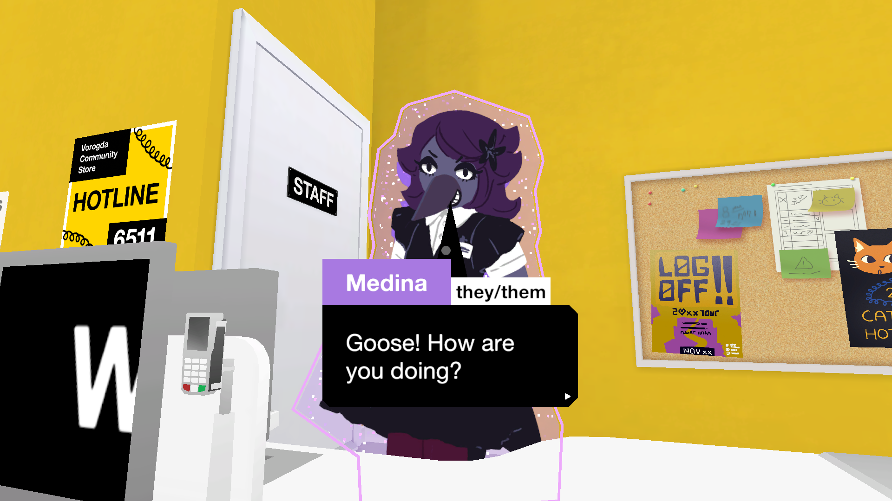

Figure - A screenshot of a character speaking in Co-Open.

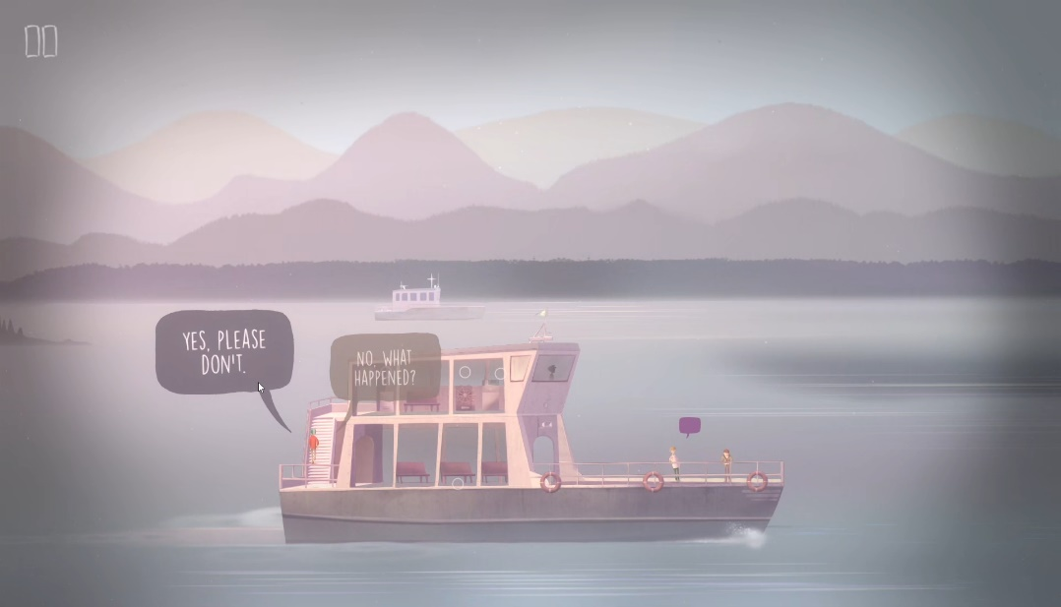

Figure - A screenshot of the player speaking in Oxenfree.

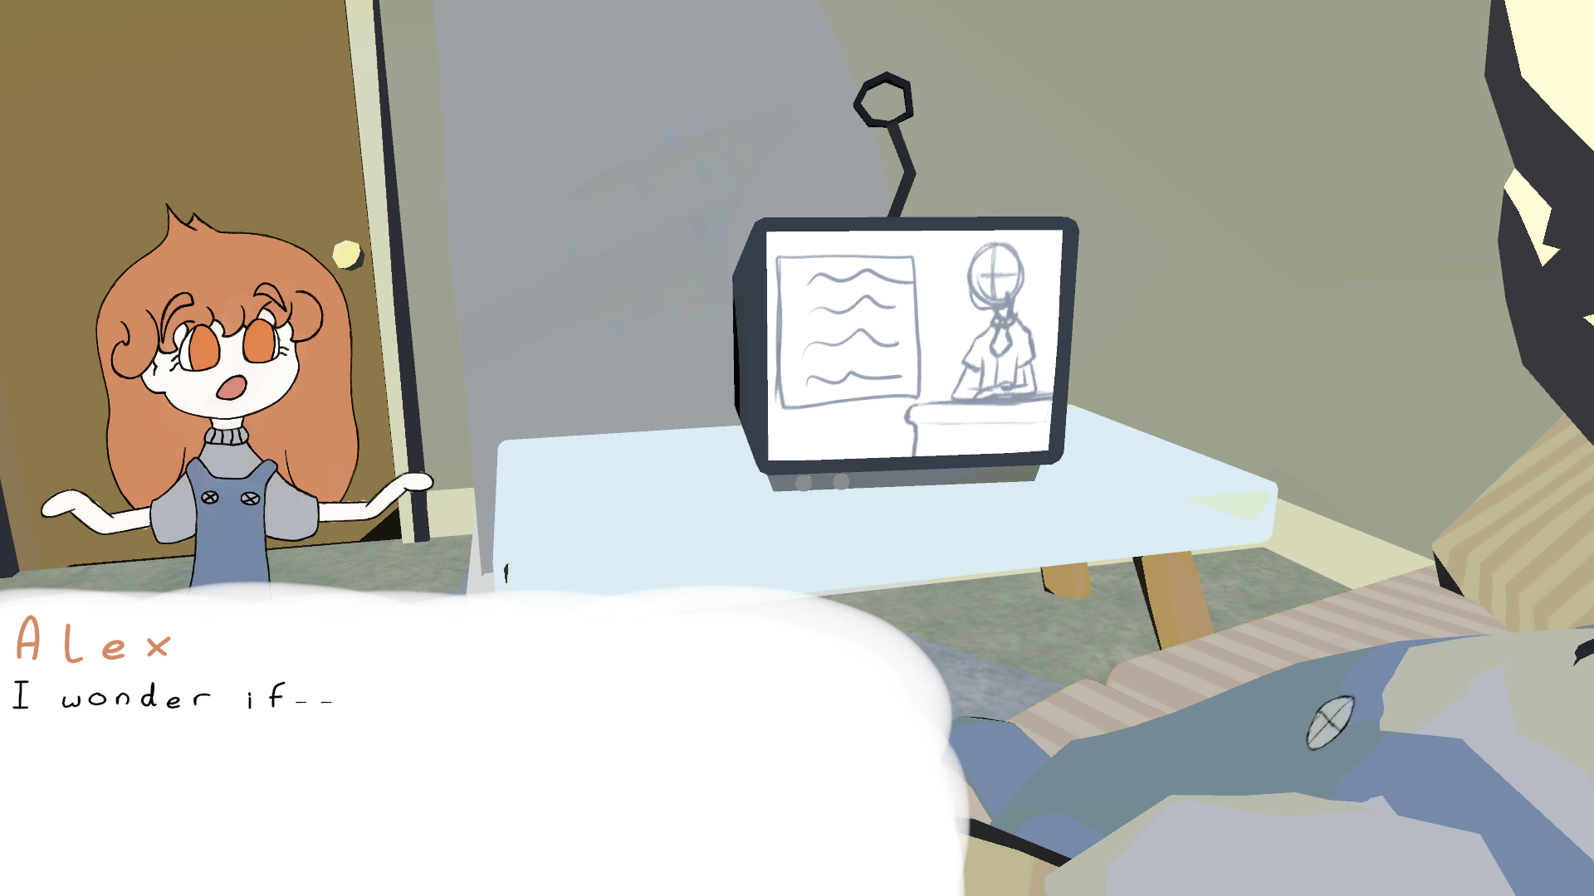

Figure - A screenshot of a character speaking in Limbo Lane.

## World interactions

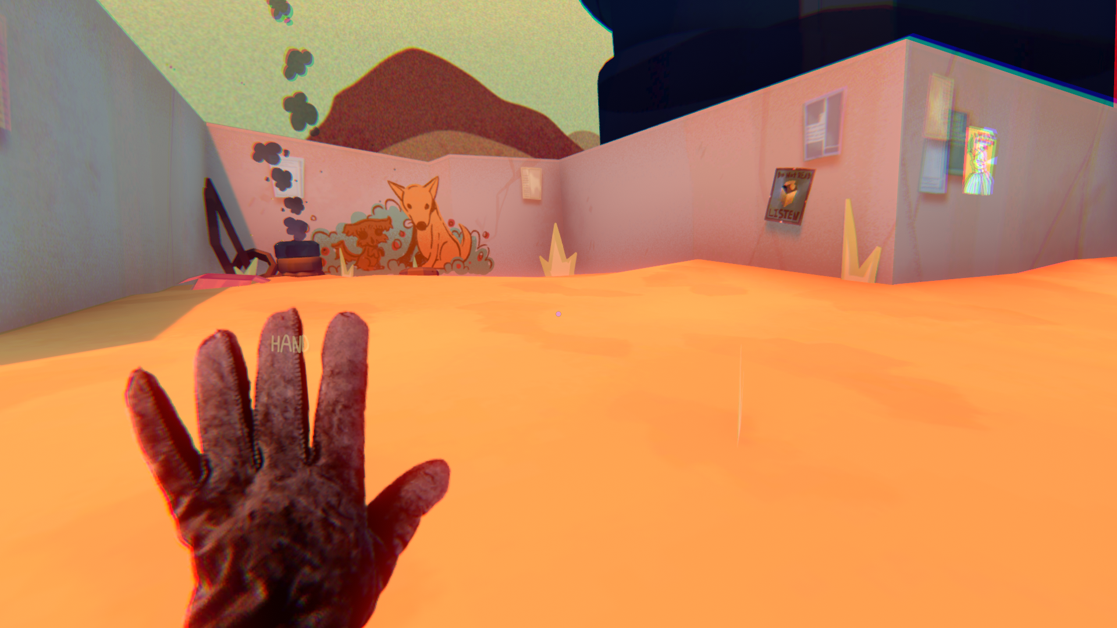

Figure - A screenshot of the grabby hand from Smile For Me.

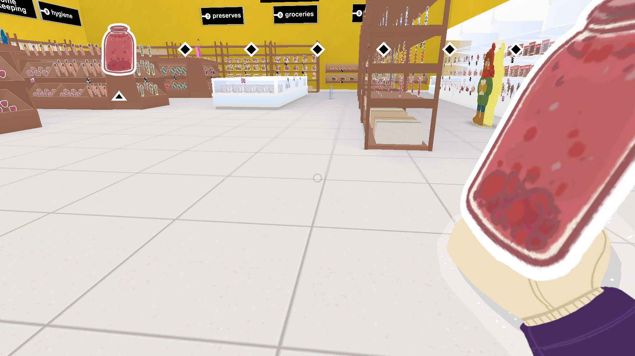

Figure - A screenshot of holding an item in Co-Open.

## Movement



Figure - A GIF showing movement in Co-Open.



Figure - A GIF showing movement in an old project of mine.



Figure - A GIF showing movement in Smile For Me.

# References

**There are no sources in the current document.**